Faculty Database

Project done under the guidance of
Prof Shankhayan Chowdhury



Department of Computer Science and Engineering,
Rajabazar Science College

By

Name :- Ishan Mukharjee Name :- Juhi Meheta
Roll No :- 91/CIS/091011 Roll No :- 91/CIS/091026
Registration Number :- 0007305 Registration Number :- 0096152
Session :- 2006-2007 Session :- 2006-2007

Name :- Hirakjyoti Banarjee Name :- Dipendu Ghosh
Roll No :- 91/CIS/091012 Roll No :- 91/CIS/091007
Registration Number :- 0007312 Registration Number :- 0000439
Session :- 2006-2007 Session :- 2006-2007

Name :- Sambuddha Das
Roll No :- 91/CIS/091008
Registration Number :- 0102902
Session :- 2006-2007

AUTHENTICATION LETTER

This is to certify that this project has been carried out at University College of Science and Technology, Calcutta (Department of Computer Science and Engineering) under the guidance of our respected project guide Dr. Shankahyan Choudhury. It also certifies that the project is an original work done by Ishan Mukherjee, Juhi Mehta, Hirakjyoti Banerjee, Dipendu Ghosh and Sambuddha Das in partial fulfillment of their course requirement at college.

- ________________________________
Ishan Mukherjee
Roll No: 91/CIS/091011
Registration No: 0007305 Of 2006-2007

- ________________________________
Juhi Mehta
Roll No: 91/CIS/091026
Registration No: 0096152 Of 2006-2007

- ________________________________
Hirakjyoti Banerjee
Roll No: 91/CIS/091012
Registration No: 0007312 Of 2006-2007

- ________________________________
Dipendu Ghosh
Roll No: 91/CIS/091007
Registration No: 0000439 of 2006-2007

- ________________________________
Sambuddha Das
Roll No: 91/CIS/091007
Registration No: 0102902 of 2006-2007

(Signature: project guide)

Dated:

Place:

Table of Contents:

Serial No. | Topics | Page No.
1 | Problem Description | 4
2 | Requirement Analysis and Specification | 6
3 | Logical Design | 9
4 | Project Description | 13

Chapter: One
Problem Definition

- Problem Definition:

Develop a faculty database system which will maintain all the details about the faculties of a particular university. It should be able to provide the following details-

- Personal details of a particular faculty. Such as name, date of birth, date of joining, qualification, home address, phone number(s), email account, photo etc.

- Conference details, i.e details about the conferences attended by different faculties. Such as conference name, conference type, starting date, finishing date, place, venue , central idea, venue type ( national / international ).

- Project details. Such as project name, topic, name of the project head, name of the organization that will fund the particular project, type of project(R&D/Commercial), stating date, finishing date and completion status.

- Publication details. Such as- publication topic, read in conference, volume number, author, journal number and publication date.

- Patent details. Such as- Patent number, topic, patent owner's name, date.

Chapter: Two
Requirements Analysis
& Specification

Software Requrements & Specifications:

- T1: Personal Details

Description: This module keeps the personal details of the teaching faculty.

T1.1: Enter the personal details/modify the details.
Input: Select “Create New“/“ Modify Existing“ options.
Output: The Initial Empty form, to enter the data / The final filled form to be updated.

T1.2: View all teacher Details.
Input: Select “View all“ option.
Output: Show all the teachers details in table form.

T1.3: View specific teachers details.
Input: Enter teacher name.
Output: Show that perticular teacher details.

- T2: Conference

Description: This module keeps the details of the conferences attended by different teaching faculties.

T2.1: Enter/ Modify conference details.
Input: Select “New Conference“ option.
Output: 1) date wise details
2) details per faculty

- T3: Projects

Description: This module keeps the details of the projects done under different teaching faculties.

T3.1: Enter/ Modify project details.
Input: Select “Enter New Project“ option.
Output: Show the “Project Details“.

T3.2: Show the projects under a specific faculty.
Input: Enter the name of that specific faculty.
Output: Show the list of projects under that specific faculty.

T3.3: Show the projects funded by a perticular organization.
Input: Enter the name of that perticular organization.
Output: Details of the projects under the entered organization.

- T4: Publications

Description: This module keeps the details of the publicastions done by different teaching faculties.

T4.1: Enter/ Modify the publication details.
Input: Select “Enter New Publication“ option.
Output: Shows the empty form.

T4.2: Shows the list of publications done by a specific faculty.
Input: Enter the name of that specific faculty.
Output: Show the list of publications done by that specific faculty.

- T5: Patents

Description: This module keeps the details of the patents taken by different teaching faculties.

T5.1: Enter/ Modify the patent details.
Input: Select “Create New Patent Entry“ option.
Output: Shows the empty form to enter patent details.

T5.2: Shows the list of patents taken by a specific faculty.
Input: Enter the name of that specific faculty.
Output: Show the list of patents taken by that specific faculty.

Chapter: Three
Logical Design
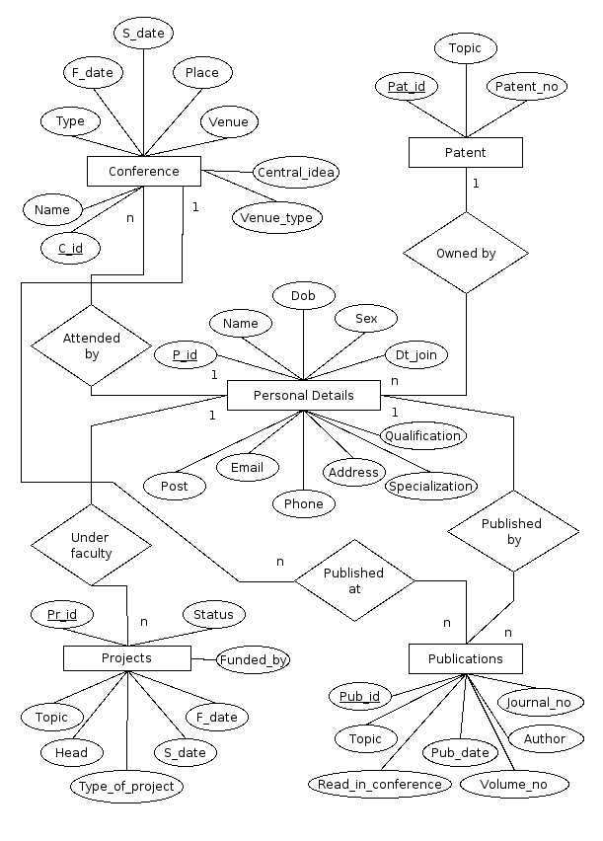
- ERD description:

Different Entities:

1. Personal_details: Personal details of a particular faculty. Such as name, date of birth, date of joining, qualification, home address, phone number(s), email account, etc.
2. Conference: Details about the conferences attended by different faculties. Such as conference name, conference type, starting date, finishing date, place, venue , central idea, venue type ( national / international ).

3. Projects: Such as project name, topic, name of the project head, name of the organization that will fund the particular project, type of project(R&D/Commercial), stating date, finishing date and completion status.

4. Publication: Such as- publication topic, read in conference, volume number, author, journal number and publication date.

5. Patent: Such as- Patent number, topic, patent owner's name, date.

Different Relations:

- Attended by: This is the relation between tables conference and Personal details. It is a many to one relationship.

- Published at: It is a one to many relationship between Conference and Publication.

- Published by: It is a many to one relationship between Publication and Personal Details.

- Under faculty: It is a many to one relationship between Projects and Personal details tables.

- Owned by: It is a many to one relationship between tables Personal details and Patents.

- Schema Description:

- Personal_details: PD_pid, name, DOB, date_of_joining, qualification, home address, phone, email.

- Conference: C_id, Conference name, conference type, starting date, finishing date, place, venue , central idea, venue type ( national / international ).

- Projects: Pr_id, project name, topic, head, funded_by, type, stating_date, finishing_date and completion_status.

- Publication: Pub_id, publication topic, read in conference, volume number, author, journal number and publication date.

- Patent: Pat_id, Patent_number, topic, name, date.

Chapter: Four
Project Description

- Data Insertion forms:

- Form 1:
Top of Form
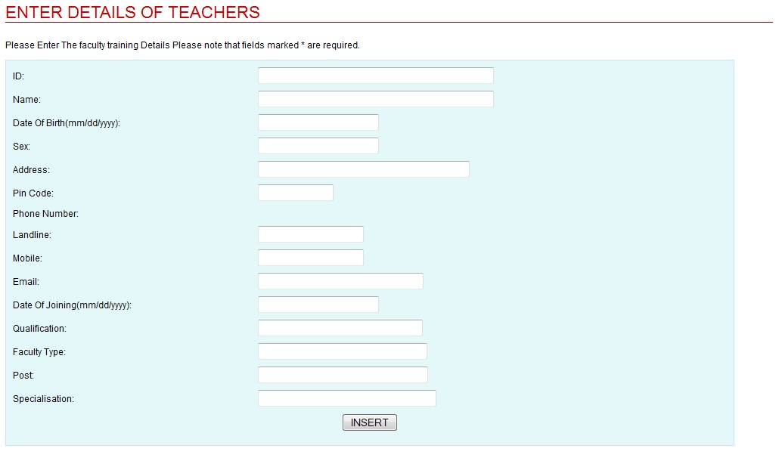

Personal Details: This form is used to insert data into the personal_details table. Name, Date of birth, sex, address, Phone number (Landline and Mobile), email account, Date of join, qualification, Faculty type, Post, Specification etc fields.

- Form 2:

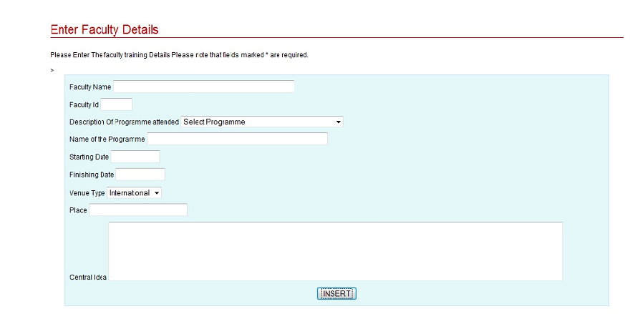

Conference: This form is used to insert details about the conferences attended by different faculties. Such as conference name, conference type, starting date, finishing date, place, venue , central idea, venue type ( national / international ).

- Form 3:

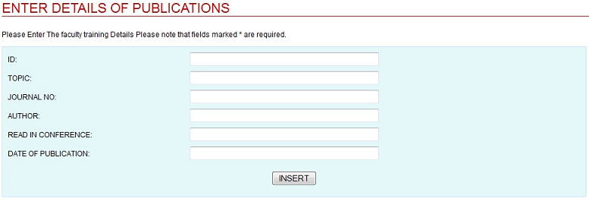

Publication: This form is used to insert data into the fields such as- publication topic, read in conference, volume number, author, journal number and publication date.

- Form 4:

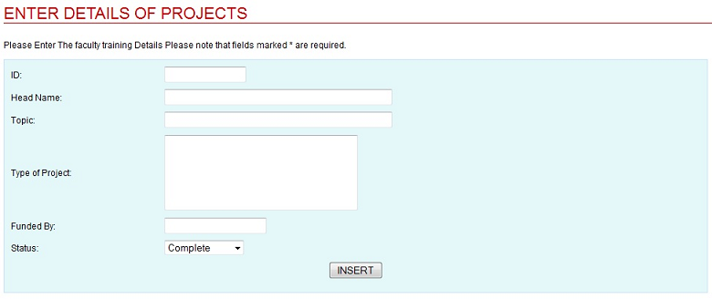

Projects: Such as project name, topic, name of the project head, name of the organization that will fund the particular project, type of project(R&D/Commercial), stating date, finishing date and completion status.

- Form 5:

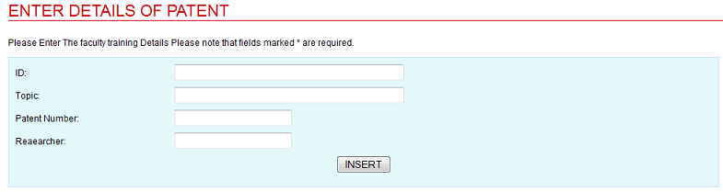

Patent: This form is used to insert data into the fields such as- Patent number, topic, patent owner's name and date.

- View forms:

- Form 1:
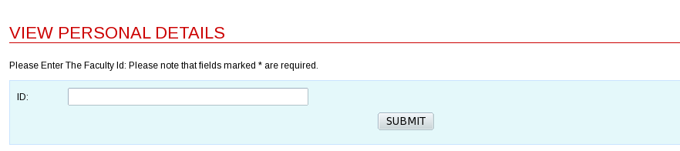

In this form, we can retrieve information about a faculty by entering his /her ID.

- Form 2:

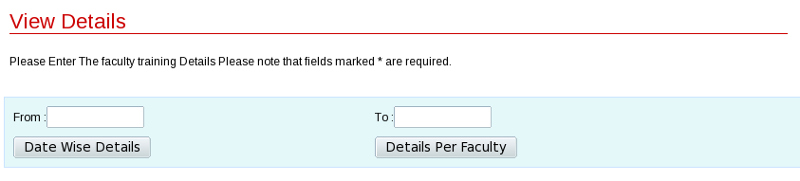

This form will show the details of the Conference taken by the faculties, by date and by faculty.

- Form 3:

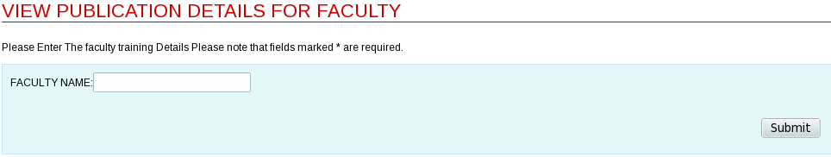

This form will show the details of the publications by different faculties.

- Form 4:

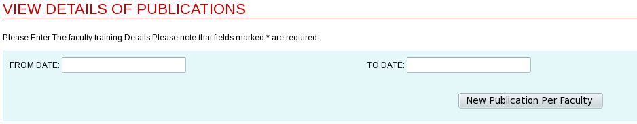

This form will show the details of the publications by different faculties from date to date.

- Form 5:

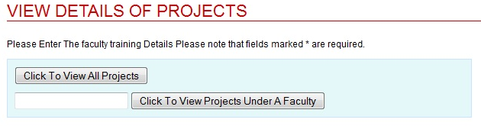

This form will show the Details of the projects.

- Report 1:

Prof S. Banerjee 12
Dr. D. Roy Chowdhury 10
Dr. B. Barua 05

- Report 2:

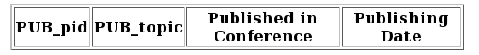
P001 Data warehousing CMM 7/03/10
P002 Data Structures CMM 7/03/10
P003 Algorithms DCPL 6/05/09

- Report 3:

- Report 4:

- Report 5:

- Report 6:

- Technology Used:

  - HTML: HTML, which stands for HyperText Markup Language, is the predominant markup language for web pages. It provides a means to create structured documents by denoting structural semantics for text such as headings, paragraphs, lists etc as well as for links, quotes, and other items. It allows images and objects to be embedded and can be used to create interactive forms. It is written in the form of HTML elements consisting of "tags" surrounded by angle brackets within the web page content. It can include or can load scripts in languages such as JavaScript which affect the behavior of HTML processors like Web browsers; and Cascading Style Sheets (CSS) to define the appearance and layout of text and other material. The W3C, maintainer of both HTML and CSS standards, encourages the use of CSS over explicit presentational markup.

